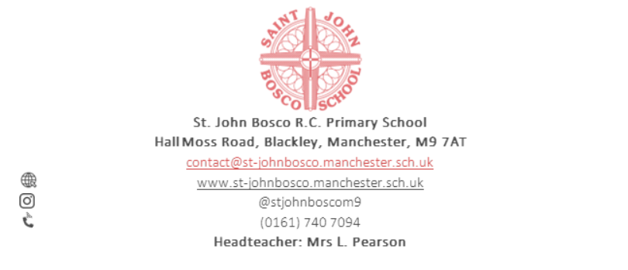

**With Jesus in our hearts, we love, pray, learn and play**

**CLASS TEACHER**

**Fixed Term, from September 2025 until August 2026 MPS / UPS Depending on experience**

**(EXPERIENCED AND NEWLY QUALIFIED WELCOME TO APPLY)**

The Governors of this popular and friendly school invite applications from suitably qualified, experienced teachers to teach in either KS1 or KS2 from September 2025. We have a dedicated, hardworking and successful team and this is an exciting opportunity for someone who wants to work with wonderful children in a supportive and welcoming environment.

We are looking for someone who:

* Is a practicing Catholic (preferred)
* Is an outstanding classroom practitioner
* Is creative, enthusiastic and resourceful
* Has high expectations for pupils’ achievement
* Puts children first and at the centre of all they do

Visits to the school are welcomed by arrangement with the Head Teacher, Mrs Pearson

Application forms and other related information is available via email from the school office at the above address. When applying please use the application form and guidance notes which can be downloaded from [our website.](http://www.st-johnbosco.manchester.sch.uk/page/vacancies/102088)

**St John Bosco is committed to safeguarding and promoting the welfare of children and young people and expects all staff to share this commitment.**

**Appointment is subject to satisfactory enhanced DBS and background check and employment is subject to satisfactory references.**

Closing date: Monday 19th May 2025 11.59pm via email to

r.glean@st-johnbosco.manchester.sch.uk

Interview and lesson observations Thursday 22nd May